MANDENI MUNICIPALITY


DRAFT
CONTRACT MANAGEMENT POLICY FRAMEWORK
2025 - 2026

TABLE OF CONTENTS

DEFINITIONS 4
GLOSSARY 6
INTRODUCTION 7

1. IDENTIFICATION AND CLASSIFICATION OF CONTRACTS 10

2. PLANNING, BUDGETING AND REPORTING 14

3. OVERSIGHT OF CONTRACT MANAGEMENT 14
3.1 Monitoring and Reporting 15
3.2 Reviews and Audits 16

4. RESOURCING CONTRACT MANAGEMENT 16
4.1 Resourcing Strategy 17
4.2 Role Clarification, Delegation of Responsibilities and Resourcing 18
4.3 Capacity, Skills and Competency Requirements 20
4.4 Code of Conduct 21

5. DOCUMENT AND INFORMATION MANAGEMENT 21
5.1 Contract Documentation 22
5.2 Standard Bidding Documents 23
5.3 Contract File 23
5.4 Contract Register 24

6. RELATIONSHIP MANAGEMENT 25

7. PERFORMANCE MANAGEMENT 27
7.1 Performance Targets 27
7.2 Delayed Performance 28
7.3 Unsatisfactory Performance 28
7.4 Dispute Resolutions 29

8. PAYMENT, COLLECTION, INCENTIVES AND PENALTIES 30
8.1 Payment and Collection 30
8.2 Incentives / Discounts for Early Payment 31

9. RISK MANAGEMENT 32
9.1 Operating Risks 32
9.2 Emerging Risks 33
9.3 Project Risks 33
9.4 Risk Assessment Workshop 33
9.5 Risk Register 34
9.6 Risk Management Strategies 34

CONCLUSION 37
CONTRACT MANAGEMENT TEMPLATES/ TOOLS/ TECHNIQUES 38

DEFINITIONS

Bid | A written offer or stipulated form, in response to an invitation by an institution for the provision of services or goods, > R200 00, in value.
Cession | Means when a contract/agreement is relinquished to another individual/institution.
Closeout | Means when a contract is considered complete and the service provider has complied with all terms and conditions of the contract, and the Institution has inspected and accepted the goods/services and/or works.
Consortium | A consortium is an association of two or more individuals/companies with the objective of participating in a common activity or joining their resources to achieve a common goal.
Contract | Agreement (explicit or implied) legally binding two or more parties to the terms of the agreement.
Contract Administrator | Means the official that is responsible for the continuous updating of the contract register and management and control of all documentation relating to the contract.
Contract Amendment | Means changing the scope, nature, duration, purpose or objective of the agreement or contract.
Contract Life Cycle | The stages of a contract encompassing planning, creation, collaboration, execution, administration and closeout or renew.
Contract Management | Means the holistic term for all activities in the contract lifecycle that is undertaken by all role players involved in a contract and include the, Contract Manager, Contract Owner, contract champion and supplier.
Contract Manager | Means the official responsible for overall contract management in an institution.
Contract Owner | Means the official that is ultimately accountable for the deliverables during the contract lifecycle relevant to the service delivery target that the contract seeks to achieve.
Contract Price | The all-inclusive price of the contract over the complete duration of the contract and includes price escalations, cost of contract variations, disbursements, VAT, etc.
Service provider | The contracting party that represents a Supplier, Service Provider or Vendor.
Deliverable | Any measurable, tangible, verifiable outcome, result or item that must be produced, delivered or constructed to meet the strategic objectives and service delivery targets of an institution.
Extension | Means when an institution decides to increase the term of a contract/agreement mutually agreed upon in writing, but for no longer than six months in terms of Treasury Regulations.
Finance Lease | A lease that transfers substantially the risks and rewards of ownership of an asset. Title may or may not eventually be transferred.
Firm Price | The price that appears on the Purchase Order and is not affected by price fluctuations due to specific industry price escalations for the duration of the contract.
Goods | Tangible movable products that are purchased from a Supplier and consumed by the institution, excluding purchases of capital assets.
Institution | Municipality or Municipal Entity.
Joint Venture | Means a business arrangement in which two or more parties agree to join together their resources for the purpose of completing a project.
Operating Lease | A lease other than a finance lease and is regarded as a current payment.
Project | The project named in the contract on the cover page.
Purchaser | The acquiring public sector entity or institution.
Quotation | An informal written or verbal offer in response to an invitation by an institution, < R200 000 in value.
Renewal | Means to allow a contract/agreement to continue for a defined period if the existing contract/agreement provides for a renewal period after the termination date.
Service Provider/ Supplier/ Vendor | The contracting party named in the contract that is required to provide goods, services and or works to the institution.
Services | The tasks to be performed by the Service Provider pursuant to the contract as described in the Terms of Reference advertised in the Invitation to Bid.
Sub-Service provider | A person or entity that enters into a subcontracting agreement with the Service Provider/ Supplier to execute part of the contract.
Table 1: Definitions

GLOSSARY

AA | Accounting Authority
AO | Accounting Officer
ASB | Accounting Standards Board
CLMS | Contract Life-Cycle Management System
CMD | Contract Management Database
ECM | Electronic Content Management
GCC | General Conditions of Contract
GRAP | Generally Recognised Accounting Practice
MFMA | Municipal Finance Management Act, Act No. 56 of 2003
MOA | Memorandum of Agreement
MOU | Memorandum of Understanding
MTEF | Medium Term Expenditure Framework
NT | National Treasury
PPP | Public Private Partnership
SBD | Standard Bidding Documents
SCC | Special Conditions of Contract
SCM | Supply Chain Management
SCOA | Standard Chart of Accounts
SLA | Service Level Agreement
TR | Treasury Regulations
Table 2: Glossary

INTRODUCTION

POLICY STATEMENT

The KwaZulu-Natal Provincial Treasury publishes this Contract Management Policy Framework (CMPF) in order to provide guidance to all Municipalities and Municipal Entities in processes related to contract management.

Government contracting shall be conducted in a manner that will:
a) Stand the test of public scrutiny in matters of discretion and integrity, encourage competition, and reflect fairness in the spending of public funds;
b) Ensure the supremacy of functioning requirements;
c) Support long-term infrastructural and local development and other appropriate national objectives, including the National Development Plan and New Growth Path; and
d) Comply with the Government's obligations under the related legislative and policy prescripts.

Purpose of the Policy

This policy framework is designed to support Municipalities and Municipal Entities in the KwaZulu-Natal Province, which, for purposes of this policy, will jointly be referred to as “entities”, in developing a sound, consistent and effective procedure to managing their diverse range of contracts. The objective of government procurement contracting is to acquire goods, services and/ or works and to carry out contracts in a manner that enhances access, competition and fairness and results in best value or, if appropriate, the optimal balance of overall benefits to the Government and the people of South Africa at large.

The intention of this Policy Framework is to define the parameters and set out a clear basis for the creation and application of appropriate processes and procedures that should result in efficient and value-adding procedures within Municipalities in accordance with the prescribed legal, financial and ethical requirements. It will assist to properly deliver the required outputs with clarity, effectiveness and accountability, and to further enable standard application of the required processes, thereby resulting in accuracy and consistency in decision-making.
In accordance with the National Treasury Contract Management Guidelines, 2010, contract management should deliberately focus on the activities associated with the operational phase of the contract after the contract has been awarded and is functional and being implemented. It is, however, fully acknowledged that successful contract management is significantly dependent on what happens before, during and after the tendering and award phases. For example, the quality of the original specification included in the bid documentation, and the agreed terms and conditions, play a critical role in enabling the effective management of the contract. Therefore, procurement planning during the tendering, contract award and the contract management phases should be seen as a continuum, with effective contract management planned from the very start of the procurement process. The policy framework is designed not only to support the application of good practice within a contract, but also to support the development and application of an effective contract management function, in general.

Scope and Application

This Policy Framework is applicable to KwaZulu-Natal Municipalities and Municipal Entities, for contracts that are valued greater than R200 000.

This framework addresses the contract management lifecycle using the policies in the following diagram:

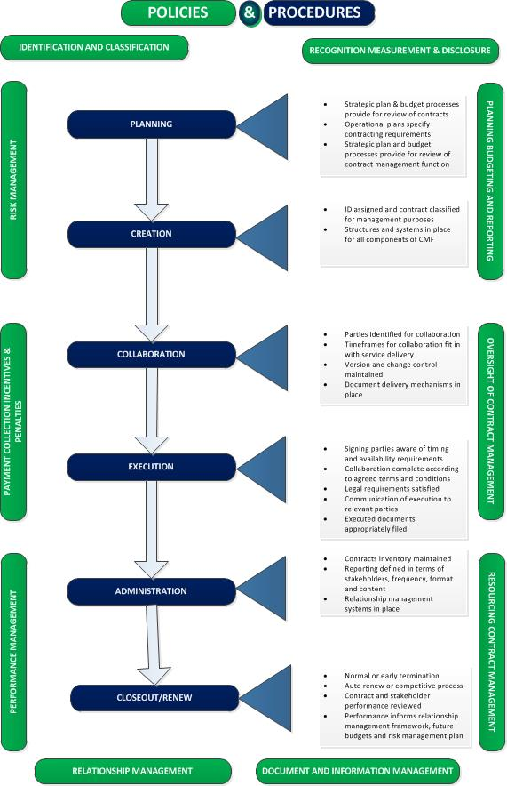
Figure 1: Contract Management Framework

IDENTIFICATION AND CLASSIFICATION OF CONTRACTS

There are two main categories of contract which are used by Mandeni Municipality for identification and classification purposes. They are Formal and Informal Contracts.

TYPE OF CONTRACT | DESCRIPTION
Formal Contracts | - A formal contract is an agreement between two or more parties and is made legally enforceable by following a prescribed format by incorporating conditions and clauses in its body.  - By entering into a formal contract, the parties are clearly defined and agree to the terms and conditions incorporated, which are clearly delineated and precisely defined in the contract document.  - Formal contracts are most reliable as the conditions within the contract limit the risk of ambiguity between the parties, which in turn offers a meeting of the minds.  - There are many types of formal contracts which can be used, depending on the type of goods, works and/or service to be provided, the timeframe of the contract, as well as the level of risk associated with executing the requirements of the agreement:  - Bilateral Agreements  An agreement between two parties, where one party agrees to act in exchange for a remunerative value.  - Service Level Agreement (SLA)  A SLA is a contract between parties, which details the nature, quality, cost and scope of the service to be provided over a specified period of time.  - Memorandum of Agreement (MOA)  A MOA is a contract between parties that defines the obligations of all parties to co-operate on an agreed upon project or meet an agreed objective.  - Tripartite Agreement  A Tripartite Agreement is a contract which shares the objective agreement between three parties. The interest of all three parties are documented and the exchange or duty of each party sealed.
Informal Contracts | - An informal contract can be defined as a contract that is not nor needs not be in a prescribed format to be legally valid or binding.  - An informal contract derives its force not from the observance of the formalities required to render it formal, but rather from the elements which fulfill the requirements of a binding contract.  - The contract is enforceable because the parties to the contract have met the requirements concerning the substance of the agreement rather than the requirements concerning the form of the agreement.  - An informal contract has the full weight of the law as long as the basic requirements of a contract have been met.
Table 3: Types and Description of Contracts

This Policy Framework provides a standard approach to the Mandeni Municipality or Municipal Entity, in the purchase of goods, services and/ or works that are similar in nature. The standard approach is based on a comprehensive analysis of contracts that institutions in the province usually enter into with respective service providers.

A further typology is provided below, on the basis of the type of contract that will best suit:
- The nature of the goods, services and/ or works being procured; or
- The nature and type of institutions that are entering into an agreement.

The types of contracts that should be used should take the form of any of the types listed below:

TYPE OF CONTRACT | DESCRIPTION
Memorandum of Understanding (MOU) | - A Memorandum of Understanding (MOU) is a legal document describing a bilateral agreement between parties.  - It expresses a convergence of will between the parties, indicating an intended common line of action, rather than a legal commitment.  - It is a more formal alternative to a gentlemen’s agreement, but generally lacks the binding power of a contract.  - It is usually selected in agreements between Public Entities or between a Public Entity and a Non-Profit Organisation, and does not involve an exchange of goods, services and/ or works for payment.
Service Level Agreement (SLA) | - A SLA is a contractual agreement that is legally binding and entered into by a Service provider and an Institution that specifies services that will be rendered, in lieu of specified payment.  - It is a contract between parties, which details the nature, quality, cost and scope of the service to be provided over a specified period of time.
Memorandum of Agreement (MOA) | - A MOA is a contract between parties that defines the obligations of all parties to co-operate on an agreed project or meet an agreed objective.  - The purpose of an MOA is to have a written understanding of the agreement between parties.  - The MOA can also be a legal document that is binding and hold the parties responsible to their commitment or simply just a partnership agreement.
Transversal Contract | - This is a contract facilitated and awarded by National or Provincial Treasury, with negotiated prices, considering the economies of scale, frequency and other variables.  - All Departments, Public Entities and Municipalities have an opportunity to participate in a transversal contract, while they retain the right to stipulate terms and conditions specific to their needs within the provisions of the main contract.
Lease | - This is a legally binding agreement through which the state will be assigned the right to use an asset owned by a service provider, for the duration of a specified period, in exchange for a series of specified payments.  - A finance lease is a lease in which all of the risks and rewards related to ownership are transferred from the lessor to the lessee.  - An operating lease is a lease in which the risks and rewards associated with ownership are not transferred to the lessee but instead are retained by the lessor.  - Contracts that are classified as leases include contracts for technological devices such as printers and photocopiers, leases for fleet, as well as contracts for property rentals.  - The parties to the lease agreement are the Lessor and the Lessee.
Umbrella Contract | - This is a type of contract where a number of service providers are appointed to a panel, from which the purchasing Municipality purchases goods, services and/ or works on an as-the-need-arises basis or on a rotational basis.  - The “umbrella contract” tends not to have a fixed price.  - As a result, it should always be accompanied by a Purchase Order that provides the price and deliverables as an annexure to the main contract.
Tripartite Contracts | - These are contracts that involve three parties.
Table 4: Types and Description of Contracts

PLANNING, BUDGETING AND REPORTING

Planning, budgeting and reporting for contract management should be aligned to and integrated into the government-wide strategic and annual planning, budgeting and reporting cycle as outlined in the Framework for Strategic Plans and Annual Performance Plans.

Planning, budgeting and reporting within contract management are strongly aligned to the broader SCM life cycle. Contract management builds on the procurement life cycle. Like procurement planning, contract management planning should take place by Quarter 3 so that plans and budgets are finalised in time for the beginning of the financial year when the Municipality’s strategic and annual performance plans and budgets have been approved. In-year reporting must include a contract review component and contracts must be disclosed in the audited annual financial statements and annual report.

OVERSIGHT OF CONTRACT MANAGEMENT

The policy framework places the responsibility of providing oversight of contract management activities on the AO of the Municipality, or the AA in the case of Municipal Entity.

The AO or AA has the primary responsibility of ensuring that the necessary systems and standard operating procedures are in place for effective contract management. They also have to ensure that contracts are planned and budgeted for, that terms and conditions of the contracts are enforced, and Government receives good value for money.

More specifically, the oversight of contract management must address the following key issues:
- The Contract Management Policy and Procedure Framework must be implemented in institutions to govern the contract management function and practices.
- Contracts must be properly enforced.
- A single person or committee must be allocated the responsibility for contract management.
- Roles for Contract Owners, Contract Managers and other stakeholders must be clearly defined.
- Appropriate delegations must be in place to allow role-players to carry out their responsibilities.
- There must be a single repository for contracts in institutions.
- A system to provide early warning signals to support the contract management process must be implemented in institutions.
- For every bid awarded to a Service provider, the following requirements must be adhered to:
- A formal contract must be entered into by the Institution with the successful bidder.
- The Contract must:
- Include GCC, which clearly define the responsibilities, obligations, etc. for all contracting parties, as well as penalties for poor performance, etc.
- Include SCC – that is clauses that may not be covered by the GCC.
- Expenditure must be managed against the contract value, the procurement plan and budget.
- Members to Panels of Service Providers, Transversal Contracts & others must have individual contracts to regulate relationships between the Service provider and Participating Institution, obligations in terms of performance against agreed service levels, payment milestones, price escalations, discounts, penalties for non-performance, dispute resolution, variations, etc.
- On-going contract management training must be provided during induction, as well as refresher training.
- Contract management policies and procedures must be reviewed at least annually.
- Institutions must ensure contract management audit queries are processed within the stipulated timeframes to achieve positive audit outcomes.

3.1 Monitoring and Reporting

Monitoring mechanisms should be put in place to ensure early identification of risks, non-delivery and poor performance by the Service provider, as well as early detection of other possible hindrances to service delivery.

The AO or AA must:
- Enforce adherence to terms and conditions; and
- Implement appropriate monitoring mechanisms that reflect the classification of the contract.
- Ensure that service provider performance reports are submitted, by project managers, to the SCM unit on a monthly basis

Regardless of how the contract monitoring is performed, accountability for accepting contract deliverables remains with the AO or AA.

Information provided by a service provider for monitoring purposes should be reviewed and audited, as necessary, to ensure that it:
- Receives regular reports on contract performance; and
- Verifies the accuracy and reliability of the report, including conducting sample audits to authenticate performance information.

3.2 Reviews and Audits

The management of contracts is conducted to, amongst other reasons, inform future procurement activities, selection of service providers to be awarded contracts, as well as to inform the choice of contract types, and the drafting of contracts. As a result, regular reviews should be conducted to determine the extent to which contracts represented good value for money, or not.
Audits of the contract should also be conducted by a different team from that responsible for contract management, in order to gauge the effectiveness of the controls that are put in place for contract management. Audits should also be extended to other stakeholders, including service providers and contract owners, regarding the quality of the goods, works and services they provided or received.

RESOURCING CONTRACT MANAGEMENT

The AO or AA must ensure that contract management activities are provided adequate resources in terms of:
- Teams and/or individuals that are dedicated to contract management and have the necessary level of senior management commitment and support. The teams or individuals should include individuals who exercise procurement delegations with experience and knowledge commensurate with the size, nature and complexity of the contracts they are responsible for;
- Requisite skills, capacity and competencies to drive contract management;
- Adequate budgets for the contract management function; and
- Enabling resources, tools and templates to facilitate contract management activities, especially records management and service provider performance management.

4.1 Resourcing Strategy

In classifying contracts, AOs and AAs will be able to identify contracts that require higher levels of management focus due to their size, level of complexity and levels of risk associated with the contract – among other things. This analysis will inform the resourcing strategy, as shown in Figure 5 below. A cross-tabulation of risk and complexity matrix suggests the following:

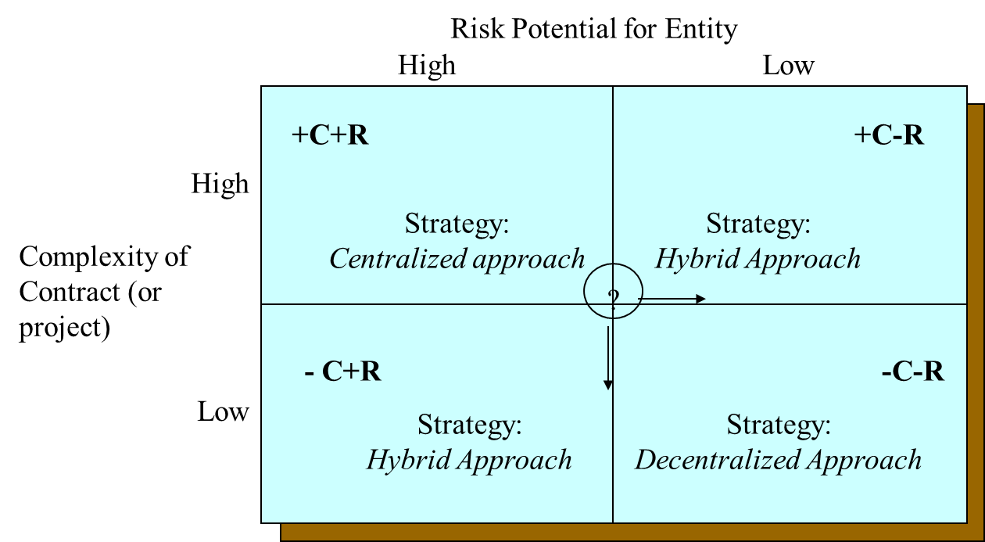
Figure 2: Classification of Contract for Determining Resourcing Strategy

- +C+R quadrant represents contracts that are highly complex and present major risks for the Municipality Failure to deliver on these contracts could have major adverse effects for Government. The recommended strategy for these contracts is to have a dedicated team assigned to managing the contract. It is important to stress that dedicated teams could either be a permanent arrangement or be assigned on a temporary basis linked to the contract.

- +C-R contracts will be highly complex but low in risk. The lowered risk could be because the entity has managed the contract before, and therefore has devised mechanisms for minimizing risks. These contracts can generally rely on institutional mechanisms for managing contracts, including a decentralized arrangement where the contract is managed by line function.

- -C+R quadrant includes contracts that are low in complexity and high in risk, and require a significant skills base with many individuals. They present high risks for a number of reasons, but are relatively less complex than others. Contracts such as those used in disaster management or distribution of food parcels could fall into this type.

- -C-R quadrant includes contracts that are low in complexity and low in risk, and can be implemented using a decentralized approach only where resources are scarce.

4.2 Role Clarification, Delegation of Responsibilities and Resourcing

The clarification of roles and responsibilities, including delegations, is central to the creation of an effective contract management system. The assignment of roles and responsibilities should be informed by:
- The level of complexity of the contract;
- The level of risk associated with the contract; and
- The duration of the contract. The AO or AA must:
- Assign teams and/or individuals to coordinate contract management; and
- Clarify roles and responsibilities in the contract management life cycle.

The typical roles and responsibilities in contract management are as follows:
ROLE | RESPONSIBILITIES
Contract Owner | The contract owner should be tasked with the following:  - Monitor the service provider’s progress and performance to ensure goods, services and/ or works conform to the contract requirements.  - Regular meetings with the service provider to review progress, discuss problems and consider necessary changes.  - Consider project reports to advise the Contract Administrator of the performance or non-performance of the service provider and risks associated with the project.  - Recommend the processing of payments consistent with the contract terms and conditions of payment.  - Participate, as necessary, in developing the bid documents (specifications, scope and standards of delivery), as well as contract documents.  - Resolve operational issues as they arise.  - Generate change requests.
- Contract Manager | The Contract Manager should be tasked with the following:  - Establish procedures and guidelines for managing all contracts.  - Authorize payments consistent with the contract terms and conditions of payment.  - Manage risks and resolve disputes in a timely manner.  - Maintain appropriate records.  - Monitor performance data and address non-conformance.  - Be the first line of dispute resolution.  - Receive and consider performance reports from the service provider.
- Contract Administrator | The contract administrator should be tasked with the following:  - Keep all contract records, including bid documents, letters of awards, purchase orders, signed contract documents and amendments or variations to the contract.  - Create and maintain the contract registers.  - Manage contract amendments and variations – including scope variations, extension of contract periods, renewal and others.  - Institute penalties and issue warning letters to non-performing service providers.  - Recommend the processing of payments after verifying performance with Contract Manager.  - Conduct regular legal and financial reviews of contracts.  - Open and close projects on the contract management system.
- Legal Services | Legal services section should be tasked with the following:  - Establish the type of contract required.  - Negotiate heads of agreement.  - Draft contract documents, based on Provincial templates and bid documents for specific contracts.  - Oversee the signing of contracts.  - Resolve disputes.
- Internal Audit | Contract reviewers should be tasked with the following:  - Conduct scheduled audits of contracts, based on the provisions of this policy framework.  - Establish if sufficient checks and balances exist in the contract management life cycle.
Table 5: Roles and Responsibilities

4.3 Capacity, Skills and Competency Requirements

The AO or AA should ensure that there is institutional capacity to drive contract management and to conduct operational day-to-day activities. At a basic minimum, the institution should have sufficient capacity to:
- provide oversight on contract management at senior management level;
- manage contracts by monitoring service provider performance to ensure delivery of goods, services and/ or works as provided for in the contract; and
- discharge administrative and operational duties associated, including creation and management of contract registers, record-keeping of all records associated with each contract, and ensuring that payments are made after due process has been followed to verify delivery of goods, services or works as provided for in the contract.

At individual level, the AO or AA must ensure that employees charged with contract management undergo the necessary training and capacity development, if necessary. The Provincial Treasury has developed a fit-for-purpose contract management training programme that has been designed on the basis of this provincial policy framework, and can be provided to officials on request.

Specialist skills that are not frequently required in the management of contracts can be sourced on an “as-the-need-arises” basis. These include customisation of standard contract ‘boiler plates’, as well as the design and management of extremely complex and rare contracts, among others. The AO or AA has the authority to source professional advice, either within the public service or externally, if they deem it necessary. However, these should be sourced in rare and complex cases and should involve skills transfer as far as possible.

In instances where an institution enlists the support of another public entity or solicits an external technically competent entity, the entity providing the expertise should be drawn in at the pre-bid stage to make input on the bid specifications and standards of delivery.

4.4 Code of Conduct

Contract management requires high levels of integrity and AOs or AAs should develop a Code of Conduct that is applicable to all those involved in the Contract Management Life Cycle.

The Code of Conduct should outline the following aspects:
- The guiding principles that employees are to follow in order to conduct themselves and their work in a moral manner;
- The responsibilities of managers in creating and maintaining an ethical working environment;
- Ethical standards for employees directly or indirectly involved in SCM activities so as to ensure that the procurement process is conducted fairly;
- Confidentiality requirements so as to ensure that no service provider is disadvantaged in any way;
- Combative practices detailing illegal and unethical practices that are prohibited; and
- Punitive measures outlining the consequences of non-compliance to the Code of Conduct.

The Code must be designed in line with the prescripts of the MFMA, SCM Regulations, as well as the Code of Conduct for SCM Practitioners. It should also pronounce on how to deal with conflicts of interest, compel service providers to sign non-disclosure agreements and prohibit all forms of gifts between the service provider and officials involved at any of the stages of the Contract Management Life Cycle.

DOCUMENT AND INFORMATION MANAGEMENT

The importance of a document and information management system in contract management can never be over emphasized. The Provincial Treasury conducted a rapid appraisal of the state of document and information management in relation to contract management, which revealed a dire picture. The management of contract documents and information was found to be varied, with some institutions struggling to retrieve even the most basic set of documents on existing contracts.

This policy framework requires AO’s and AA’s to maintain sound records, document and information management systems for contract management. It is recognized that most institutions will have manual, paper-based systems rather than electronic ones. The litmus test is the extent to which information can be retrieved from the system when required. Highly sophisticated and costly systems should not be rushed into. Institutions should aim to create a culture of contract management, using basic systems that yield the desired results. Migration to sophisticated systems can be done gradually once the fundamentals are in place.
The Provincial Treasury requires institutions in the province to maintain a system that can provide the basic minimum set of information outlined below, to ensure that audit and probity requirements are met. Institutions are at liberty to expand their contract management information beyond the basic minimum set in order to meet other obligations that they might have.

5.1 Contract Documentation

- A valid contract is concluded and becomes binding when a bidder’s bid is accepted by the institution against an official purchase order and a signed letter of acceptance, by an authorised person, has been sent before the validity period has expired.
- The contract concluded must consist of:
  - The GCC issued by the National Treasury;
  - Where applicable, SCC that enhance the GCC in relation to the specific goods, services and/ or works procured;
  - Submitted bid documents;
  - Documentation for the claiming of preferential procurement points;
  - Tax clearance certificate; and
  - Letter of acceptance.

- Contracts relating to information technology must be prepared in accordance with the State Information Technology Act, 1998 (Act 88 of 1988), and any regulations issued in terms of that Act.

5.2 Municipal Bidding Documents

All contracts must be based on the GCC, issued by the National Treasury. Where no relevant municipal bidding documents (MBD) have been issued, the Municipality should use other internationally recognised standard contract forms acceptable to the AO or AA, in concurrence with the KZN Treasury.

The standard wording of the GCC must not be amended. The municipal bid documentation and GCC issued by the Construction Industry Development Board must be utilized in cases of bids related to the construction industry.

The bid documents should clearly state the type of contract to be entered into and contain the appropriate contract provisions. The most common types of contracts provide for payments on the basis of lump sum prices, unit prices, reimbursable costs plus fees, or combinations thereof.

Reimbursable cost contracts should be acceptable only in exceptional circumstances, such as contracts with conditions of high risk or where costs cannot be determined in advance with sufficient accuracy. Such contracts should include appropriate incentives to limit costs and may only be concluded subject to the approval of the AO or AA.

5.3 Contract File

A contract file should be opened for each contract that includes the following documentation:
- Letter of Award;
- Purchase Order;
- A contract, signed by all parties post-award;
- All correspondence between the contracting parties;
- Record of payments;
- Evidence of delivery as provided for in the agreement;
- Record of amendments to the contract (including extension of time frames or expansion of scope);
- Record of reviews and audits conducted on the contract; and
- Risk assessment reports, where applicable.
- Bid document
- Letter of Acceptance

5.4 Contract Register

A contract register should be created and updated regularly. This register should include the following information:
- Contract identifiers (unique ID, corresponding bid/ quotation/ requisition number and purchase order number);
- Contract type and category;
- Service provider identifiers (Name of appointed bidder, central supplier database registration number, type of service provider);
- Description of Goods/Services/Works/Projects;
- Contract Value (if applicable, include percentage escalation and any other financial value);
- Contract period (start date, end date, duration, extension date where applicable, and early termination date where applicable); and
- Payment history (milestones/deliverables, actual dates of payment, payment penalties levied).

Internal Audit should conduct scheduled audits of the document and information systems that are set up in an institution. The audit should verify that:
- Checks and balances are being implemented for system access controls designed to ensure unauthorised employees do not have access to, and cannot amend or alter, contract information.
- Contract files and contract registers exist, and are a true record of the status of the contracts.
- Payments are made on the basis of verifiable proof of delivery of goods, services or works as provided in the contract.
- The institution conducts periodic quality assurance reviews of the information in the register.
- Payments are made in accordance with the terms and conditions set forth in the contract agreement.

RELATIONSHIP MANAGEMENT

Relationship management in the contract life-cycle should involve a deliberate effort by all parties to ensure that Government’s risk is minimised and that Government’s resources are managed effectively, efficiently and economically as required by the MFMA.

Relationship management involves the relationships between the purchasing institution, service provider’s and all the relevant officials, such as Contract Managers, Legal Advisors, Contract Owner’s and Senior Management.

The type of contract, its size and duration, as well as the culture of the parties and the personalities of the people involved, will influence the relationship between the parties. A framework for determining the type of relationship for contract management has been developed based on the level of specialisation and the accompanying level of responsiveness that is depicted in the figure below:

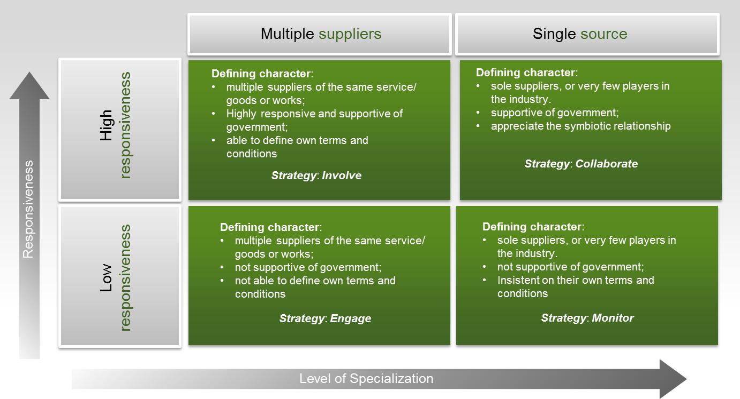
Figure 3: Classification of Type of Relationship Management Approach

It is best practice for institutions to adopt a structured approach to managing their relationship with the service provider, which should consist of:
- Informal, day-to-day discussions and interactions between the service provider, the Contract Manager, Contract Owner and relevant staff; and
- Formal meetings at pre-determined intervals with nominated personnel from both the Institution and the Service provider.

PERFORMANCE MANAGEMENT

The aim of performance management is to ensure that:
- The service provider performs in accordance with the standards previously agreed upon;
- The service provider is meeting their obligations stipulated in the contract;
- Issues and problems are identified early in order for remedial actions to be implemented; and
- Price and payment terms are being adhered to.

Prior to the contract commencing the parties should discuss and agree upon the policies and procedures to be used in measuring performance. These policies and procedures must be set out in the contract. The level of performance management will depend on factors such as:
- Contract value;
- Duration of the contract;
- Expertise of the personnel involved;
- Level of risk associated with the contract;
- Size and nature of the contract;
- The goods, services and/ or works to be provided; and
- Type of contract.

7.1 Performance Targets

In order to determine the KPI’s, it is necessary to:
- Identify the institution’s objectives and desired outcomes;
- Specify the inputs, activities and outputs necessary to achieve the institution’s objectives and desired outcomes;
- Select indicators that will measure critical inputs, activities, as well as key outputs; and
- Ensure that the selected indicators are manageable and that the required data is easily available.

Once the KPI’s have been defined they are used to specify performance targets which the institution aims to achieve within a specific time period. The performance targets need to be:
- Specific and clearly identifiable;
- Measurable;
- Achievable;
- Relevant and linked to a desired outcome; and
- Time bound.

Performance standards also need to be set so as to identify the minimum level of performance that will be accepted by the institution. The performance standards and targets should be specified in the contract document and communicated to all parties prior to the commencement of the contract.

7.2 Delayed Performance

The GCC provides that the service provider must perform in accordance with the contract specifications within the time schedule set out in the contract. If at any time during the contract period, the service provider is unable to perform in a timely manner, the service provider must notify the institution in writing of the cause of and the duration of the delay. Upon receipt of the notification, the institution should evaluate the circumstances and, if deemed necessary, the institution may extend the service provider’s time for performance which will constitute an amendment to the contract. The institution may decide to impose a delay penalty.

In the event of delayed performance that extends beyond the delivery period, the institution is entitled to purchase commodities of a similar quantity and quality as a substitution for the outstanding commodities, without terminating the contract, as well as return commodities delivered at a later stage at the service provider’s expense. Alternatively, the institution may elect to terminate the contract and procure the necessary commodities in order to complete the contract.

In the event that the contract is terminated the institution may claim damages from the service provider in the form of a penalty. The service provider’s performance should be captured on the service provider database in order to determine whether or not the service provider should be awarded any contracts in the future.

7.3 Unsatisfactory Performance

When an institution is not satisfied or there are problems with the service provider’s performance, the institution must:
- Review the conditions causing the problems and determine whether or not the institution itself has significantly contributed to the problem;
- Review the contract and other relevant documentation in order to identify the rights and responsibilities of each party; and
- Notify the service provider in writing that their performance does not comply with the terms and conditions set out in the contract.

The written notification sent to the service provider should clearly identify the following:
- The problem so as to avoid any misunderstanding;
- The corrective actions that are to be taken;
- The time frame allowed for the service provider to address and correct the problem; and
- The consequences that would arise in the event that the problem is not corrected within the specified period.

7.4 Dispute Resolutions

The institution can apply different measures during the preparation and administrative phases of the contract in order to avoid any problems that may lead to a dispute. These measures include the following:
- Stating the contractual requirements, such as specifications and delivery dates, as clearly as possible;
- Using plain and clear language in the contract itself, as well as all other contract documentation;
- Addressing issues or problems as and when they arise to prevent them escalating; and
- Maintaining a good working relationship with the service provider.

The policies and procedures with regards to dispute resolution should be detailed in the contract and agreed to by both parties. The resolution options should be listed in order of preference starting with the least severe method moving towards more severe methods.

PAYMENT, COLLECTION, INCENTIVES AND PENALTIES

Payment provisions including the value to be paid, the schedule of payments, as well as payment procedures as agreed upon by all parties, must be stipulated within the contract. The types of payment schedules include payments made at regular intervals throughout the contract period or when agreed deliverables or outputs are achieved.

8.1 Payment and Collection

The GCC states that the service provider must submit an invoice together with a copy of the delivery note, as evidence of the commodities being delivered and accepted.
- All amounts owed by the institution must be paid within thirty (30) days, unless stated otherwise within the contract, after the receipt of invoice.
- In the case of a civil claim, all payments must be settled within thirty (30) days from the date of settlement or court judgement.
- In the event that the institution fails to pay within the prescribed period, it will be in breach of the contract. Only amounts under dispute can be withheld by the institution.
- The Contract Manager must review all invoices submitted by the service provider in order to determine the validity of the costs claimed, as well as evaluate the total contract expenditure incurred against the actual progress of the contract.
- The Contract Manager must file a copy of all invoices and payment vouchers, if applicable, with the contract documentation for record purposes.
- In addition, the Contract Manager must maintain a payment register for each contract.
- The payment register is used to record all payments made to the service provider, as well as the balance of the contract value.
- The receipt of monies due to the institution must be closely monitored and in the event that monies are not received within the specified terms, immediate action must be taken in order to recover all outstanding amounts.

8.2 Incentives / Discounts for Early Payment

In some instances service providers provide discounts for invoices settled within a period of 30-days. Contract Managers must negotiate these discounts vigorously, and ensure that if indeed payment is made within 30-days, the discounts are deducted from the remaining contract amount.

In the event that the service provider fails to deliver any or all of the goods, services and/ or works within the time frame specified in the contract, the institution will be able to penalise the service provider. The penalty is based on the delivery price of the outstanding goods, services and/ or works and uses the current prime interest rate to calculate an amount for each day that the delivery is outstanding up until the goods, services and/ or works are delivered to the institution. The penalty amount is deducted from the contact value.

Both incentives and penalties are used by the institution in order to meet its objectives. An incentive is used as a method of encouragement while a penalty is used as a form of discouragement. It is important that both incentives and penalties are enforced uniformly.

RISK MANAGEMENT

Risk is defined as uncertainty of outcome, whether this is positive (i.e. an opportunity) or negative (i.e. a threat).

It is important that a thorough risk analysis is conducted at the signing of the contract agreement and a risk management plan is designed to run parallel to the implementation of the contract. In contract management, managing risk means identifying and controlling the factors that may have an impact on the fulfilment of a contract. Risks can relate to any aspect of the contract and include fluctuations in demand, lack of service provider capacity, changes to your requirements, industry standards or to legislation and the transfer of staff.

Risks may be classified as:
- Operating risks that the institution and the service provider may encounter during the operational phase of the contract. These may be further categorised as environmental risks, health and safety risks, financial and investment risks, demand risks, employment risks and performance risks;
- Emerging risks that are unknown during the procurement process but which will come to light and require management during the life of the contract; and
- Project risks that will need to be managed during the procurement process, and, if appropriate, the construction or implementation phase of the project. These need to be managed separately.

9.1 Operating Risks

These are the risks that will need to be allocated between the institution and the service provider. One should follow the general principle that risks should be placed with the party best placed to manage them, remembering that wherever risk is transferred to or shared with the service provider, they will very likely require a commensurate compensation or reward.

The Contract Manager will need to compile and maintain a risk register for these risks. Once that is done he/ she will need to determine how best to allocate these risks, i.e., which risks are best transferred to the service provider, which are best retained by the institution and which are best shared by the parties and to what degree. Remember that one cannot hope to transfer all risks to the service provider. Not only would it be impractical, it would also be too expensive.
Again, the project team members and key stakeholders need to come to a view on this allocation prior to issuing the contract bid documents in the procurement process. This is because the allocation of risks needs to be clearly captured and dealt with in the terms and conditions of the contract and should inform both the development of the specification and the performance management framework.

9.2 Emerging Risks

The problem with unforeseeable risks is that it is not known what they are going to be until they occur. Nevertheless, the institution and the service provider will need to agree on a process by which they will evaluate and allocate new risks as they emerge during the operational phase of the contract.

The best way to handle an emerging risk, as it comes to light, is to try to align it with a similar risk that is already clearly treated in the contract. If the risk shows characteristics that are similar with other risks that have already been agreed upon, then it would seem sensible to treat it in the same way. Clearly, there is a chance that an emerging risk will be totally new and different and one will have to negotiate and agree with the service provider who will bear responsibility for it, or whether and in what proportions it will be shared.

9.3 Project Risks

The Contract Owner will need to compile a separate register for project risks, i.e. those risks that may be foreseeable during the procurement process and, if appropriate, construction or implementation phase of the project. It will be the Contract Owner’s responsibility to oversee the management of these risks. The participants of the risk assessment workshop can help determine:
- Possible mitigating steps the project team can take to minimise each risk; and
- The estimated time and cost of each mitigating step.

9.4 Risk Assessment Workshop

The workshop must be attended by all members of the project team and the key stakeholders. The following steps will be followed:
- Brainstorm all possible risks – get the workshop members to list as many as they can think of - then classify them as operating risks and project risks.
- Each participant should then independently score (a) the potential impact and (b) the likelihood of each risk occurring, perhaps on a scale of 1 to 5.
- By multiplying the average scores for each risk, you can rank the risks in order of magnitude and importance.

9.5 Risk Register

During the procurement process there is a need to compile and maintain two risk registers to capture the likelihood, impact and mitigation of all identified risks, one for operating and emerging risks and one for project risks. The Contract Manager should continue to maintain and update the risk register throughout the operational phase of the contract, retiring operating risks that have been fully mitigated and adding emerging risks as time goes on.

Share the risk register with the service provider and encourage them to use it. They can then jointly operate the process for identifying emerging risks, developing and implementing mitigating actions and subsequently retiring them as appropriate.

Together, they should review all high- and medium-level risks routinely at regular review meetings.

9.6 Risk Management Strategies

Contract risk must be appropriately managed such that:
- All contracts set out risk identification, monitoring and escalation procedures and mechanisms which are in line with the institution’s Enterprise-Wide Risk Management Framework;
- All contracts identify contingency plans for service provider failure;
- The Contract Manager monitors the financial health, tax compliance and overall performance of the Service provider; and
- Contract terms and potential ramifications around key issues including termination, warranty, indemnity, security, confidentiality and dispute resolution are understood by the Contract Manager.

In longer-term more complex contracts, the Contract Manager will also need to prepare for the risk of potential changes in law or changes in the political landscape that might not be immediately foreseeable, for example, a merging of local municipalities or the transfer of responsibilities and powers between local, district, Provincial and National Government.

The following are some examples of risks and their associated risk management strategies:
RISK | RISK MANAGEMENT STRATEGY
Unauthorised and irregular expenditure | - In order to manage expenditure against the budget and procurement plan and to avoid the incurrence of unauthorised and/ or irregular expenditure, it is essential that the contract price is calculated accurately.  - This price is the price tendered by the service provider and used in the calculation of price points when applying the formula prescribed by PPPFA.  - It should be the amount extracted from the Comparative Pricing Schedule. However, where there are unforeseen delays in the bid evaluation and adjudication processes, the price offered by the bidder may change due to the lapse of time.  - Where there is an amendment, variation, extension or renewal of this contract, the financial implication must be calculated and inserted on the Price Schedule, provided that the budget is made available and the Procurement Plan is updated accordingly.
- Service provider’s ability to execute the contract | - The Bid Committees should demonstrate that sufficient due diligence was conducted to verify that the service provider is a going concern with the necessary resources to discharge its contractual obligations and is fully compliant in terms of tax laws and registration requirements.  - In addition, the Institution should monitor these on a regular basis for the duration of the contract.  - In the event the service provider is unable to deliver – for any reason – there should be a clear articulation of the alternative delivery mechanisms that will be invoked by the service provider.  - Risks associated with the contract may include, but are not limited to, the following:  - The service provider fails to adhere to the budget agreed upon;  - The service provider fails to comply with the provisions contained within the contract;  - The service provider lacks key staff members thus eroding the quality of the deliverables;  - The service provider’s delivery is disrupted by factors outside of their control, such as a natural disaster;  - The service provider’s financial standing may deteriorate thereby decreasing their ability to meet the terms of the contract;  - The institution may lack the capacity to receive the commodity;  - The institution’s demand for the commodity may fluctuate drastically; and  - The institution’s requirements are changed fundamentally, such as a change in policy.
Table 6: Risk Management Strategies

In order to mitigate risk the institution compiles a contingency plan in order to maintain essential services. The contingency plan will be an express requirement for all contracts that exceed a value to be determined by the Provincial Treasury.

CONCLUSION

Contract management should deliberately focus on the activities associated with the operational phase of the contract after the contract has been awarded and is up and running. However, it is fully acknowledged that successful contract management is significantly dependent on what happens before, during and after the tendering and award phases.

Procurement planning during the tendering, contract award and the contract management phases should be seen as a continuum, with effective contract management planned from the very start of the procurement process.

Organisations in both the public and private sectors are facing increasing pressure to reduce costs and improve financial and operational performance. New regulatory requirements, globalisation, increases in contract volumes and complexity have resulted in an increasing recognition of the importance and benefits of effective contract management.

CONTRACT MANAGEMENT TEMPLATES/ TOOLS/ TECHNIQUES

APPENDIX 1: | Risk Register
Table 3: Contract Management Templates/ Tools/ Techniques

This policy has been considered and approved by the COUNCIL OF MANDENI LOCAL MUNICIPALITY as follows:

Resolution No:………………………….
Approval Date:.....................

